BARBIE BUNGEE!!!! MSDS Summer 2021!!!!!

Virtual Hybrid Style!

|  |  |  |  |  |  |  |  |  |  |  |  |  |  |  |  |  |  |  |  |
| --- | --- | --- | --- | --- | --- | --- | --- | --- | --- | --- | --- | --- | --- | --- | --- | --- | --- | --- | --- |
| 1.STEP 1 … GATHER THE DATA   |  |  | | --- | --- | | Number of Rubber Bands | Distance Bungeed | | 2 | 22 | | 3 | 24.5 | | 4 | 32 | | 5 | 35 | | 6 | 39 | | 7 | 44 | | 8 | 48 | | 9 | 55 | | Team Name: __Iron Man_____  Teammate:   1. __Kevin Albright____________________ 2. __Linda Urrutia________________________ 3. __Cleveland Johnson_______________ |
| You need a:  1. Dropper 2. Spotter 3. Recorder  Every group member should help with the calculations! |

2. Step 2: Create a fully labeled scatter plot in R (preferably with ggplot) and paste it in the box below.

|  |
| --- |
|  |

1. Conduct a hypothesis test to test the claim that the linear correlation coefficient / slope is different than zero. Show all 6 steps! Fill in the blanks:

|  |  |
| --- | --- |
| $$Ho: β_{1}= _0_$$ $$Ha: β_{1}≠ _0__$$**Critical Values: = $±$_______**  **Test Statistic: 6.35**  **Pvalue: 0.0003849**  **Decision:** Reject Ho | **Conclusion: There is sufficient evidence to conclude that the slope is different from zero. P-value: .0003849** |

4. Was the linear correlation significantly different than zero? How do you know? _Yes. As the number of rubber bands increased, so did the distance.________

6. What is the estimate of the percent of the variation in the distance bungeed that is explained by the number or rubber-bands used? __98.9%_______

7. Calculate and write down the linear regression equation (if appropriate) (don’t use “y” and “X” … use “Distance” and “Num_RubberBands”: **distance = 12 + 4.625(num of rubber_bands)**

8. Use R to find a confidence interval for the slope. Write the interval below as well as the margin of error (MOE). You can use the easy calculation for the MOE: (upper limit – lower limit) / 2

**Lower limit: 4.181**

**Upper limit: 5.069**

**MOE: .444**

9. Interpret the slope and the interval you found above:

**For every one rubber band added, the distance traveled will increase by 4.625 inches.**

**We are 95% confident that the distance travelled for every one rubber band will be between 4.181 and 5.069 inches.**

10. Interpret the intercept:

**With no rubber bands, the distance travelled will be 12 inches**

11. Would using the interpretation about the intercept be extrapolation? Why or why not?

**It would be extrapolation, as the first observation we performed was 2. Anything lower than two would be considered extrapolation.**

12. Next … you have the opportunity to collect a little more information! You may take one more jump but this time we have a longer tape measure. Simply choose the number of rubber bands you want to test and line up to collect your extra data point. NOTE: You are increasing the variance of X (number of rubber bands)!: sx2 .

What number of rubber bands did you use in this extra drop? ___23_____ -> distance= 133

What is the sx2? ___39.2_____

13. Next recalculate the intercept and slope using all your data points and write the new regression equation below.

**Slope: 5.35**

**Intercept: 8.24**

14. What is the new confidence interval for the slope now that you have used all your data points? Recalculate the MOE and compare it to the one you found earlier. Which one is smaller?

**Lower: 5.056**

**Upper: 5.64**

**MOE: .292**

**The previous Margin of Error was smaller**

15. Provide a plot of your data with the regression line.

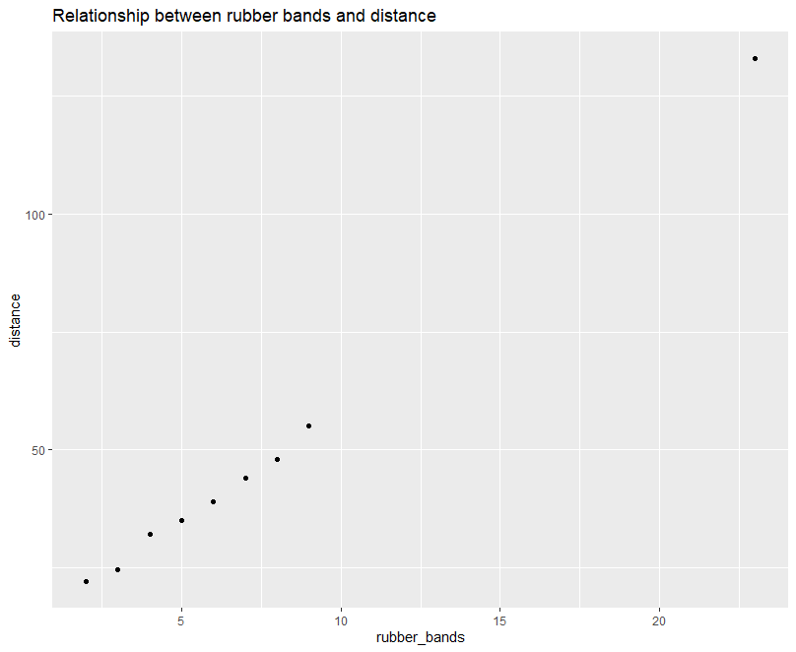

16. **Email this back to Bivin for Immersion credit! bsadler@smu.edu.**

17 We have measured the distance from the top to the bottom of the Hughes Trigg Bridge! It is 22ft 4 inches. Use your regression equation to estimate the number of rubber bands needed to bungee your super hero or Barbie that distance. The winner will bungee their subject closest to the ground without hitting any body part. Remember that it is ok if hair hits the ground but any other body part (hand, head, etc.) results in death or serious injury to super hero or Barbie and disqualification for you team! ☺

**268 = 8.24+5.349(rubberbands)**

**48 rubber bands are required**

18. Start stringing those rubber bands together … then we are off to the Hughes Trigg Bridge!!!!!